Job Description: | Demolition Saw | Date: | 06-02-2026 | Risk Rating: Medium
Name, & Contact Details:  Robertson’s Remedial and Painting Pty Ltd  Unit 10/56 Buffalo Road  Gladesville NSW 2111  Phone: (02) 9181 3519  A.B.N 16 140 746 247 |  | Site Location:  6a Francis Street, Bondi Beach
Name & Phone Number of Person Completing SWI: Ben Knox (0408 253 832)
Name & Phone Number of the Person Supervising the Work: Matthew McCarthy (0413 636 000)
Comments; This Safe Work Instruction (SWI) is to be used in conjunction with the Safe Work Method Statement for the task being performed. Operating instructions from the supplier of plant are to be obtained and followed.

Procedure  (In Steps): | Possible Hazards: | Risk Score | Safety Controls: | Residual Risk | Responsible Person
Preparing for use of Demolition Saw | Untrained or unlicensed workers may access site causing serious injury to self or other individuals | Medium  (3) | All workers must have General Construction Induction Certificate  All workers must complete site induction upon arrival to site and sign in.  All workers to be trained in and sign safe work instruction and read the operators manual and be familiar with the use of the saw.  Only experienced, trained and competent persons to operate Demolition Saw.  All workers to be in a fit state to commence work, they must be zero blood alcohol concentration and must not be suffering from fatigue or under the influence of drugs.  Operators are not to work alone minimum two workers to be present. | Low  (1) | Workers and Supervisor
Preparing for use of Demolition Saw | Inappropriate tool and equipment allocation may lead to injury | Medium  (3) | Ensure adequate first aid kits and amenities are available.  Demolition saw to be inspected prior to use to ensure that the guard is in place correctly and not damaged. The blade is in good condition and not worn down, out of shape, missing segments, damaged or cracked. The emergency stop is working, the trigger is functioning correctly and there is no damage to the saw.  Check the locking nut is secure and that the blade is installed correctly with the arrows facing the direction of rotation and where necessary the flange is in place and in good condition. The blade selected must be appropriate for the material being cut and the saw that it is being installed on ie as per the manufacturers instructions, is not too big or small and ensure that when cutting through metal a suitable blade is used. Set up the water and ensure there is adequate flow prior to use. Do not operate in wet weather | Low  (2) | Workers and Supervisor
Working outdoors | Weather conditions and UV Exposure | Medium  (3) | Workers must remain hydrated through regularly drinking water.  Workers to stay out of sun where possible and implement rest breaks or job rotation where necessary.  Workers to consider stopping work in extreme heat.  Workers must wear appropriate PPE including: sun cream, sun hats, long sleeve shirts, long pants and sunglasses while working outside. All workers to wear hard hat eye protection, high visibility safety vest and steel capped boots. | Low  (1) | Workers
Secure work area to ensure public do not access | Injury to public or workers due to individuals entering work site | Medium  (4) | Appropriate barriers to be erected to prevent public access to work area.  Appropriate signage to be erected indicating work site unauthorised access not permitted.  Hoses and leads not to be run across walkways, driveways (keep secure in work zone)  Ensure clearance of 15m in front of and behind the blade or barriers in place.  Do not operate from a ladder or above shoulder height  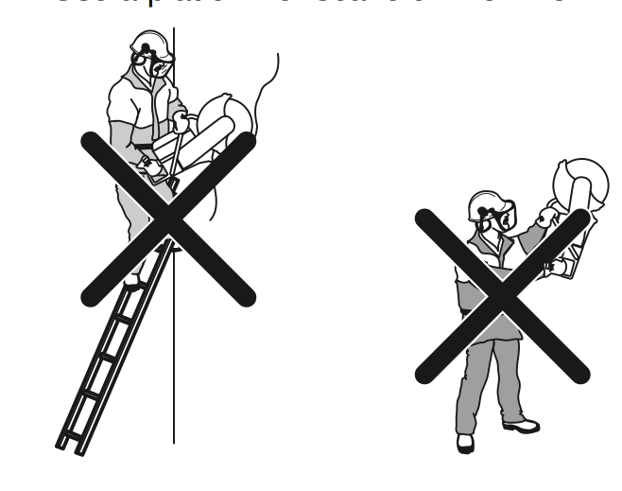  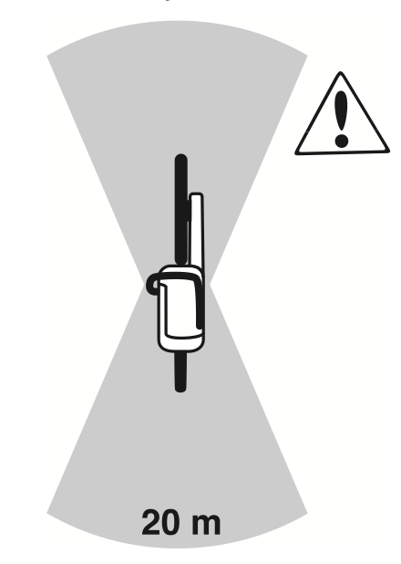 | Low  (2) | Workers
Unload materials and equipment from vehicle and position in work area | Manual handling injury | Medium  (4) | Use gloves that will ensure good grip and protect the hands from vibration and injury  Workers to follow the correct manual handling procedures when lifting:  - Use mechanical lifting devices and trolleys where possible  - Only lift objects within your safe lifting limit (use team lifts where needed)  Clear a path, assess the load, get a good grip, ensure a wide stance, bend the knees, keep the spine strait, use the legs to lift, do not twist the trunk, use a smooth action, brace the stomach muscles and lower. | Low  (2) | Workers
Filling fuel tank of demolition saw | Possible fire while refuelling | Medium  (3) | Petrol and its vapours are extremely flammable, allow engine to cool at least 2 minutes before refuelling and always use fresh petrol.  Use funnel or can with spout when filling petrol.  Take care with filling to ensure no spills occur and clean them up or remove clothing if spills occur.  Do not over fill fuel tank. Return fuel to a secure position.  Check for fuel leaks.  Move at least 3m away from fuelling area before starting | Low  (2) | Workers
Prior to operating demolition saw | Injury due to equipment failure | Medium  (4) | Pre start visual inspection of equipment to be completed prior to commencement as outlined above. Remove from service or repair if damaged.  Keep all body parts, clothing and hair clear of moving machinery.  Ensure machine has current test tag and is plugged into a RCD  Ensure water does not run into machine and cause damage.  Do not use in atmospheres where flammable materials are present. | Low  (2) | Workers
Prior to operating demolition saw | Noise | Medium  (3) | Hearing protection to be worn at all times | Low  (2) | Workers
Prior to operating demolition saw | Body parts may be damaged | Medium  (3) | Always wear safety glasses or goggles and protective face shield, hard hat and hearing protection  Long sleeve shirts and long pants to be worn. Steel capped boots must be worn. | Low  (2) | Workers
Prior to operating demolition saw | Dust inhalation | Medium  (3) | Water to be used to minimise dust  Where dust is present operators to wear dust mask  Wet vac and slurry bags to be used to contain waste where necessary | Low  (1) | Workers
Starting saw | Possible cuts, bruises or fractures if body parts come into contact with saw or out of control material | High  (6) | When starting the saw ensure that the blade is not touching the ground as it will spin when it is started.  Ensure all persons are a safe distance away.  Press the decompression switch and choke where necessary.  Place the right foot on the handle and push into the ground, place the left hand on the top handle and firmly hold and push down (as illustrated above)  Do not wrap the cord around the hand, pull the cord slowly until pressure is on the cord then pull but not to hard and do not pull all the way to the end of the cord or release quickly.  Check to ensure the saw is running smoothly and allow time to warm up. | Medium  (3) | Workers
Operating Demolition Saw | Possible cuts, bruises or fractures if body parts come into contact with saw or out of control material | High  (6) | Keep all body parts, clothing, hair and jewellery clear and ensure that saw is held tight.  Stay alert, watch what you are doing and use common sense when Sawing.  Stop immediately if you feel there are any safety issues.  Do not use while tired or under the influence of drugs, alcohol, or medication.  Take a firm grip with two hands. Ensure adequate water flow.  Adopt a comfortable stance, with feet apart and well balanced, and with a clear view keep head up and body to the side of the blade.  Allow the saw to "run up" to operating speed before applying it to the job.  Hold the saw against the work piece with minimum pressure, so it doesn't "dig in" and cause it to kick back.  Feed down the machine in the direction of the blade do not apply pressure sideways as this may cause kickback from skewing the blade as indicated below.  Frequently back the saw out of deep cuts to clean and cool the blade  Never operate above shoulder height  Never put a saw down until the blade stops rotating. | Medium  (3) | Workers
Operating demolition saw | Kickback: Kickback is the sudden upward motion that can occur if the blade is pinched or stalled in the kickback zone. A kickback can be very violent and throw the power cutter up and back towards the user in a rotating motion causing serious or even fatal injury | High  (6) | The work piece must always be supported so that the cut stays open when cutting through. When the cut opens there is no kickback. If the cut closes and pinches the blade there is always a risk of kickback  Take care when inserting the blade in an existing cut.  Be alert to movement of the work piece or anything else that can occur, which could cause the cut to close and pinch the blade.  Take care with reinforcement mesh as this may increase risk of kickback.  Never cut plastic pipe as it may melt and stick to the blade causing kickback.  Never operate in the kickback zone as indicated below the top ¼ of the blade  Release the trigger immediately if there is a jam.  Ensure all work pieces are secured to prevent movement.  When cutting large objects (i.e. concrete pipes), ensure they are positioned on supports to allow the object to be cut in small gradual sections- do not attempt to cut the object in one single cut.  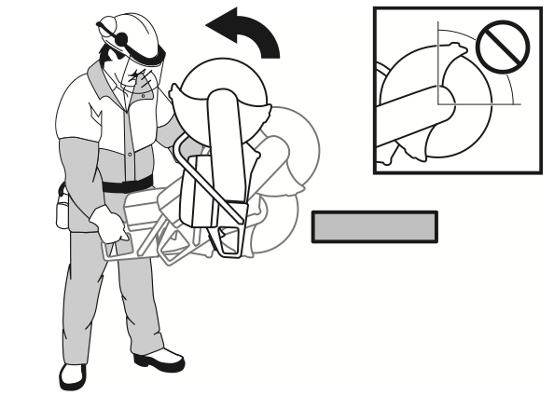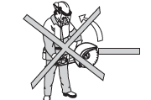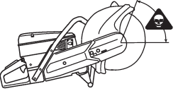 | Medium  (3) | Workers
Operating demolition saw | Asphyxiation from fumes | High  (6) | Engines emit deadly carbon monoxide gas only use in well ventilated area open windows, vents, or doors.  Never use in enclosed areas or confined spaces without appropriate breathing apparatus. | Low  (2) | Workers
Operating demolition saw | Manual handling risk | Medium  (3) | Use correct manual handling technique as outlined above | Low  (2) | Workers
Operating demolition saw | Repetitive strain and muscular injury due to repetitive work and prolonged fixed postures | Medium  (4) | Workers must warm up and stretch prior to commencing work.  Workers to rotate tasks to avoid repetitive tasks and fixed postures.  Workers to avoid excessive straining and over reaching. | Low  (2) | Workers
Operating demolition saw | Electrocution or injury due to exposure to underground services or cables | High  (6) | Prior to commencement of work isolate lock out and tag out necessary services.  Prior to commencement of work any underground services to be identified and located All workers to allow for inaccuracies in the plans and drill with caution  Once identified services should be clearly marked and isolated.  Operator to take care while drilling to spot any cables etc | Low  (2) | Workers
Clean up site | Injury to workers | Medium  (3) | All tools and equipment to be secured and locked up at end of use. | Low  (1) | Workers
Clean up site | Manual Handling hazard | Medium  (4) | Use gloves that will ensure good grip and protect the hands from vibration and injury  Workers to follow the correct manual handling procedures when lifting:  - Use mechanical lifting devices and trolleys where possible  - Only lift objects within your safe lifting limit (use team lifts where needed)  Clear a path, assess the load, get a good grip, ensure a wide stance, bend the knees, keep the spine strait, use the legs to lift, do not twist the trunk, use a smooth action, brace the stomach muscles and lower. | Low  (2) | Workers

Personal Protective Equipment (PPE) required: | Enclosed leather steel capped boots (As per AS/NZS 2210)  Safety Glasses (As per AS/NZS 1336)  Hearing protection (As per AS/NZS 1269)  Padded gloves (As per AS/NZS 2161)  Dust masks where necessary (As per AS/NZS 1716)
Training and Qualifications required by workers to complete the work: | General Construction induction certificate (White card)  Induction into SWI
List the Permits, Certificates, SafeWork NSW Approvals, required to completed the work:
Relevant legislation:  For further details refer to the Legal Requirements Register | Work in accordance with Work Health and Safety Act 2011 and Work Health and Safety Regulation 2025, workplace injury management and workers compensation act 1998, Workers Compensation Regulation, AS/NZS1337.1 Personal eye protection-Eye and face protectors for occupational applications, AS/NZS 1269.3 Occupational Noise management-Hearing protection program, AS/NZS 1801 industrial safety helmets, AS/NZS 2210.1 Safety, protective and occupational footwear-Guide to selection, care and use (2010) & AS/NZS 2210.2 to 2210.9 Occupational protective footwear.  Safe Work Australia Codes of Practice  - Construction Work  - Work Health and Safety Consultation, Co-operation and Co-ordination  - Managing the Work Environment and Facilities  - First Aid in the Workplace  - Hazardous Manual Tasks  - Managing Noise and Preventing Hearing Loss at Work  - How to manage Work Health and Safety Risks
Hazardous Substances | Fuel
Plant/equipment that will be used on site:  Maintenance checks for plant & equipment: | Demolition Saw
Frequency of site/workplace inspections: | Daily site inspections to be completed by Site Supervisor
The control measures implemented will be reviewed in consultation with workers and or others who may be affected by the SWI. Any changes to the SWI will be communicated with workers at induction, daily pre-starts and toolbox talks.

Sign Off and Approvals

Person responsible for site supervision of the work, inspecting and approving work areas, approval of and compliance with SWI, protective measures, plant, equipment:
Name and position: | Signature:
SWI Prepared by: Ben Knox – Compliance OH&S | Signature: 

Risk Level | Description of consequence or impact | Consequence | Likelihood/Probability
Risk Level | Description of consequence or impact | Consequence | Unlikely (1) | Possible (2) | Almost Certain (3)
High  Level of harm | Actual/Potential fatality, disability or irreversible damage. Major structural failure/damage. Off-site environmental discharge/release not contained and significant long-term environmental harm. | Major (3) | Medium  (3) | High  (6) | High  (9)
Medium  Level of harm | Actual/Potential temporary disability, MTI or LTI. Structural failure/damage, >1-day outage. On-site environmental discharge/release contained, minor remediation, short-term environmental harm. | Moderate (2) | Low  (2) | Medium  (4) | High  (6)
Low  Level of harm | Incident that has the potential to cause persons to require first aid. Environmental discharge/release immediately contained, minor level clean-up with no short term environmental harm. | Minor (1) | Low  (1) | Low  (2) | Medium  (3)
Level | Likelihood/Probability
Almost Certain | Occurs frequently; >66% chance of occurring
Possible | Could happen occasionally; >33% but <66% chance of occurring
Unlikely | May occur only in exceptional circumstances; <33% chance of occurring
Class/Ranking | Description/Requirements
High 6, 9 | Stop immediately. Implement permanent preventative controls.
Medium 3, 4 | Will require operational planning. Actions will be recorded on a SWI.
Low 1, 2 | Will require detailed pre-planning. Actions will be recorded on a SWI. Will require localised control measures.

SWI has been developed using the hierarchy of controls to reduce the risk and likelihood of an incident/injury occurring. The use of Elimination, Substitution,
Engineering/isolation, Administrative and PPE measures will be used in the above order of preference wherever practicable.

Induction confirmation:

This SWI has been developed in consultation with the workers and has been read and signed by all workers involved in this activity. I note that I have read and understood the above safe work instruction and will ensure work is completed accordingly.

Date: | Name: | Signature:

